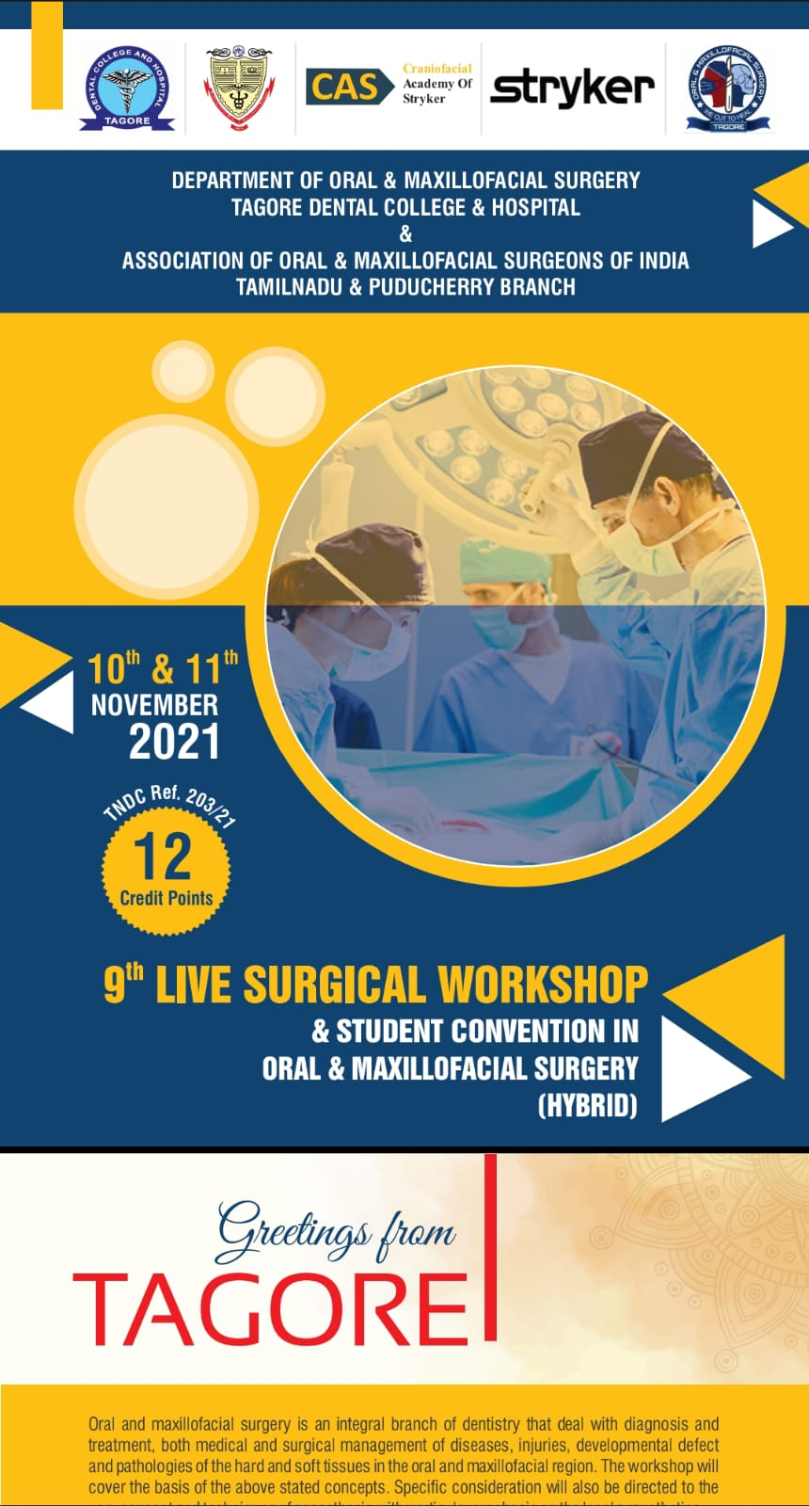
DEPARTMENT OF ORAL AND MAXILLOFACIAL SURGERY
TAGORE DENTAL COLLEGE AND HOSPITAL
MELAKOTTAIYUR POST, RATHINAMANGALAM
CHENNAI – 600127
PH: 044 – 3010 2222, EXTN: 228 / 230
EMAIL ID: maxfacs@tagoredch.in

PROF.M.MALA PROF.DR.VENKATAKRISHNAN
CHAIRPERSON PRINCIPAL
ORGANIZING COMMITTEE:
PROF.DR.S.JIMSON
DR.B.LOKESH
DR.B.ANANDH
DR.BALAKRISHNA
DR.MEERAN SHARIF
DR.ISRAEL NATHANAEL
DR.JONES JAYABALAN
DR.JEDIDIAH FREDRICK ABISHEG

Organizer:
Department of Oral & Maxillofacial Surgery
Tagore Dental College & Hospital
Date: 10th NOVEMBER & 11th NOVEMBER 2021
Learning Outcome: To acquire detailed knowledge about surgical removal of impacted teeth, oral biopsy, implant surgery and Mandibular fractures

Guest Speakers:
1. DR. SURESH KUMAR P
Consultant
Department of Oral and Maxillofacial Surgery

2. DR.KARTHIK.R

Professor,

Department of Oral and Maxillofacial Surgery
SRM Kattankalathur Dental College & Hospital
Chennai

3. DR.NACHIAPPAN

Professor,

Department of Oral and Maxillofacial Surgery
Sathyabama Dental College & Hospital
Chennai

4. DR. N.VIGIL DEV ASIR

Professor,

Department of Oral and Maxillofacial Surgery
Shree Balaji Dental College & Hospital
Chennai

5. DR.P.PRASANNA KUMAR
Professor and Head,

Department of Oral and Maxillofacial Surgery
Coorg institute of dental sciences and hospital
Karnataka

6. DR.CHITRA CHAKRAVATHY

Professor,

Department of Oral and Maxillofacial Surgery
Navodaya Dental College & Hospital
Karnataka

7. DR.ANUJ DADHICH

Professor,

Department of Oral and Maxillofacial Surgery
Rural Dental College
Maharasthra

8. DR.SAURABH MOHAN KAMAT

Professor,

Department of Oral and Maxillofacial Surgery
Goa university
Goa

9. DR.PRITHVI.S.BALEPUR

Consultant,

Oral and Maxillofacial Surgeon
Bangalore

10. DR.KAVITHA SURESH

Professor and Head,

Department of Oral and Maxillofacial Pathology
Meenakashi Ammal Dental College and Hospital
Chennai

11. DR.SATHISH KUMARAN.P

Professor ,

Department of Oral and Maxillofacial Pathology
M.R Ambedkar Dental College and Hospital
Bangalore

TOPICS COVERED:
- SURGICAL REMOVAL OF IMPACTED TEETH
- ORAL BIOPSY
- IMPLANT SURGERY
- MANAGEMENT OF MANDIBULAR FRACTURES

PROGRAM SCHEDULE DAY 1

TIME | PROGRAM
8.30-9.00 AM | REGISTRATION
9.00-10.30 AM | SURGICAL REMOVAL OF IMPACTED TEETH  DR.KARTHIK.R  MODERATORS :  DR.P.PRASANNA KUMAR  DR.CHITRA CHAKRAVARTHY
10.30-11.15 AM | INAUGURATION
11.15-11.30 AM | TEA BREAK
11.30-1.00 PM | ORAL BIOPSY  DR.VIGIL DEV ASIR  MODERATORS:  DR.KANNAN.R  DR.KAVITHA SURESH
1.00 – 2.00 PM | LUNCH BREAK
2.00-5.00 PM | PAPER PRESENTATION (U.G/P.G)

Day 1 - The program started with the welcome speech by Dr.S.Jimson followed by the Principal’s speech by Dr.C.J.Venkatakrishnan . The felicitation of the faculties of the program was done. Dr.S.Jimson Dr.C.J.Venkatakrishnan. The first session started by 9.am followed by the other sessions. A Panel discussion between faculties of three different disciplines was held by 10.30 AM which included Dr.P Prasanna Kumar, Dr.Chitra Chakravarthy And Dr.Karthik.It was an intense and highly informative discussion on the surgical removal of impacted teeth . The Inauguration was held at 10.30 AM .A short break was observed by 11.15am .Soon after the break the next surgery demonstration started by 11.30AM. A Conclusive panel discussion on the days topics were discussed by Dr.Vigil Dev Asir , Dr.Kannan.R And Dr.Kavitha Suresh. Lunch break was held from 1.00pm to 2.00 Pm. The UG/PG Paper presentations were started at 2.00 pm and held finished by 5.00PM

PROGRAM SCHEDULE DAY 2
TIME | PROGRAM
9.00-10.00 AM | PAPER PRESENTATION
10.00-11.30AM | IMPLANT SURGERY  DR.SURESH KUMAR.P  MODERATORS :  DR.PRITHVI.S.BALEPUR  DR.SAURABH MOHAN KAMAT
11.30-11.45 AM | TEA BREAK
11.45-1.15 PM | MANDIBULAR FRACTURES  DR.NACHIAPPAN.S  MODERATORS:  DR.ANUJ DADHICH  DR.SATHISH KUMARAN.P
1.15 – 2.00 PM | LUNCH BREAK
2.00-5.00 PM | PAPER PRESENTATION  VALEDICTORY FUNCTION

Day 2: The program started with the welcome speech by Dr.S.Jimson followed by the Principal’s speech by Dr.C.J.Venkatakrishnan. The paper presentation started by 9.am followed by the other session’s .The implant surgery was started 10.00 Am and was done by 11.30 Am. The surgery was done by Dr.Suresh Kumar .P and the moderators for the session were Dr.Prithvi.S.Balepur and Dr.Saurabh Mohan Kamat.it was an intense and highly informative discussion on implant surgery .A short break was observed by 11.30am .Soon after the break the next surgery demonstration started by 11.45AM. The surgery was done by Dr.Nachiappan.S and the moderators for the session were Dr.Anuj Dadhich and Dr.Sathish Kumaran.P . Lunch break was held from 1.15pm to 2.00 Pm. The UG/PG Paper presentations and the valedictory function were started at 2.00 pm and held finished by 5.00PM.

ATTENDANCE SHEET: 9th live surgical WORKSHOP 10.11.2021 DAY 1
SHRUTHI VIJAYAN | PRIYADARSHINI S | THOUNAOJAM SUSHMA DEVI
SAKTHI S | DHULIPUDI.RACHANA | SAM SUJIL
THENNARASU A R | PARVATHANENI DATTA PRASAD | DHARMENDRA TIWARI
V.JAYASHREE | TEJASWI RAAVI | AKSHYA PRIYA. A
R.S.JANURTHIKA | P KRANTHI MAYI | DEVADHARSINI RAVIKUMAR
SOUNDARYA | JOSHUA PALLAPATI | FATHIMA S.
R.SANDHIYA | HEMANTH REDDY | R DEVISREE
SINDUJA | MUTHALAGAPPAN PL | L. KOMAL
S.JENCY ABARNA | SHOBICA.E | SHAMEEN DUBA
P.M.SASTIMANI | RATHNAPRIYA B | SHRUTI. E
SHWETA RANJITH | SNEGHA. A | SUNITHA CAROL.J
AAMINA AFRA | DR. SHRISHMA. L. V | SHWETHA MOHAN
KADAMBARI R | DR SURIYA KUMAR N | ANANDHAN
KUDIARASI RAJENDRAN | GEORGE SAMYO STEPHENSON | JOHANAS PETER
MADHU BALA SERMARAJAN | ROSE REX | BALA KARTHIGA .V
SANTRA JOSEPH | S.SUREKHA | D.SWETHA
ADITHI KARTHIKEYAN | SYLVIA OINAM | ELANCHEZHIYAN P
D.SANJANA | EVANGELIN IDA | FARHEIN FATHIMA DHASTAGIR
M KISHAN KUMAR | GETHSIYAL X | KRISHNA PRABHA G
SOPHIA.S | PAUL KEVIN ABISHEK | MALAVIKA JAYARAMAN
J RAKSHANAA | RAJESHWARI | VANDANA
PAVITHRA LAKSHMI N | SWETHA V | BANUCHANDAR J
SHRUTHI VIJAYAN | DR. BISMI AMLAJ | RAMYA. P

ATTENDANCE SHEET: 9th live surgical WORKSHOP 11.11.2021 DAY 2
SHRUTHI VIJAYAN | PRIYADARSHINI S | THOUNAOJAM SUSHMA DEVI
SAKTHI S | DHULIPUDI.RACHANA | SAM SUJIL
THENNARASU A R | PARVATHANENI DATTA PRASAD | DHARMENDRA TIWARI
V.JAYASHREE | TEJASWI RAAVI | AKSHYA PRIYA. A
R.S.JANURTHIKA | P KRANTHI MAYI | DEVADHARSINI RAVIKUMAR
SOUNDARYA | JOSHUA PALLAPATI | FATHIMA S.
R.SANDHIYA | HEMANTH REDDY | R DEVISREE
SINDUJA | MUTHALAGAPPAN PL | L. KOMAL
S.JENCY ABARNA | SHOBICA.E | SHAMEEN DUBA
P.M.SASTIMANI | RATHNAPRIYA B | SHRUTI. E
SHWETA RANJITH | SNEGHA. A | SUNITHA CAROL.J
AAMINA AFRA | DR. SHRISHMA. L. V | SHWETHA MOHAN
KADAMBARI R | DR SURIYA KUMAR N | ANANDHAN
KUDIARASI RAJENDRAN | GEORGE SAMYO STEPHENSON | JOHANAS PETER
MADHU BALA SERMARAJAN | ROSE REX | BALA KARTHIGA .V
SANTRA JOSEPH | S.SUREKHA | D.SWETHA
ADITHI KARTHIKEYAN | SYLVIA OINAM | ELANCHEZHIYAN P
D.SANJANA | EVANGELIN IDA | FARHEIN FATHIMA DHASTAGIR
M KISHAN KUMAR | GETHSIYAL X | KRISHNA PRABHA G
SOPHIA.S | PAUL KEVIN ABISHEK | MALAVIKA JAYARAMAN
J RAKSHANAA | RAJESHWARI | VANDANA
PAVITHRA LAKSHMI N | SWETHA V | BANUCHANDAR J
SHRUTHI VIJAYAN | DR. BISMI AMLAJ | RAMYA. P

ATTENDANCE PERCENTAGE:
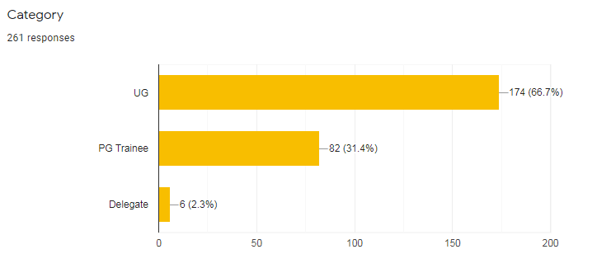

PROGRAM FEEDBACK:

